CERTIFICATE OF DELIVERY

DATE | 01/05/2026
EQUIPMENT | CW tester

PHOTO | ITEM | CANT
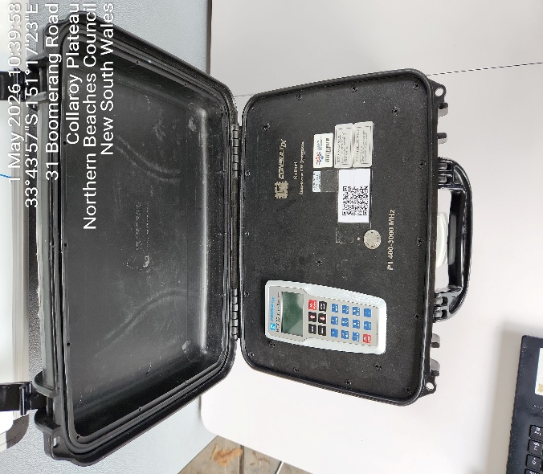 | High Power Kit  Safari Consultix  SN: C1907SB111394 | 1
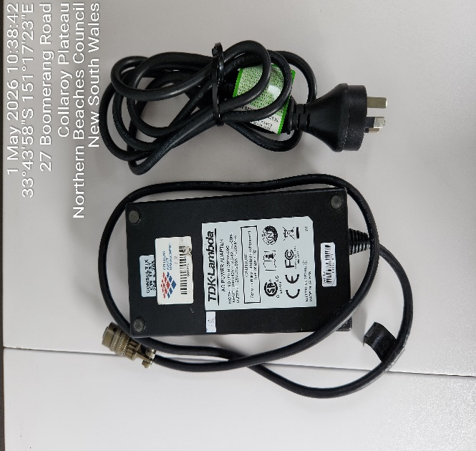 | Ac Power Suply  DTM165PW280C | 1

COMMENT:

